**Git Module 2, Assignment 4**

**To Do :**

● Put master.txt on master branch, stage and commit

● Create 3 branches: public1, public2 and private

● Put public1.txt on public 1 branch, stage and commit

● Merge public 1 on master branch

● Merge public 2 on master branch

● Edit master.txt on private branch, stage and commit

● Now update branch public 1 and public 2 with new master code in private

● Also update new master code on master

● Finally update all the code on the private branch

**Solution :**

Mkdir asst4

Cd asst4

Touch master.txt

Git add master.txt

Git commit –m “added master.txt to master branch”

Git push origin master

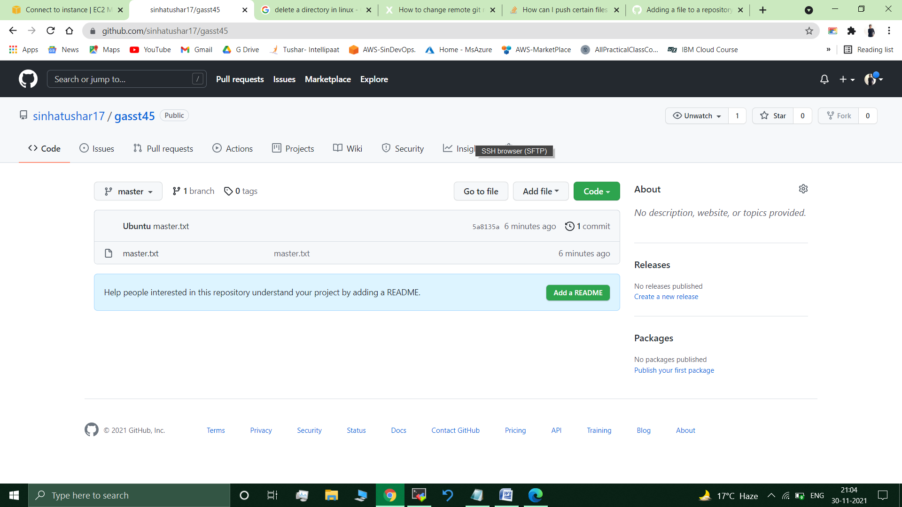

git branch public1

git branch public2

git branch private /Created all required branched.

git branch // * master, private, public1, public2

git checkout public1

touch public1.txt

git add public1.txt

git commit –m “pub1.txt added”

git push origin public1 //public1.txt added to public1 branch of repo.

//Merging branches.

On master branch

git merge public1

git merge public2 //already up to date

git checkout private

ls //master.txt present

vi master.txt //Editing master.txt in private branch ( Added the following lines : --This is my firs edit in this main.txt file after merging pub1 & pub2 branch to master

-done by - sunny.) //

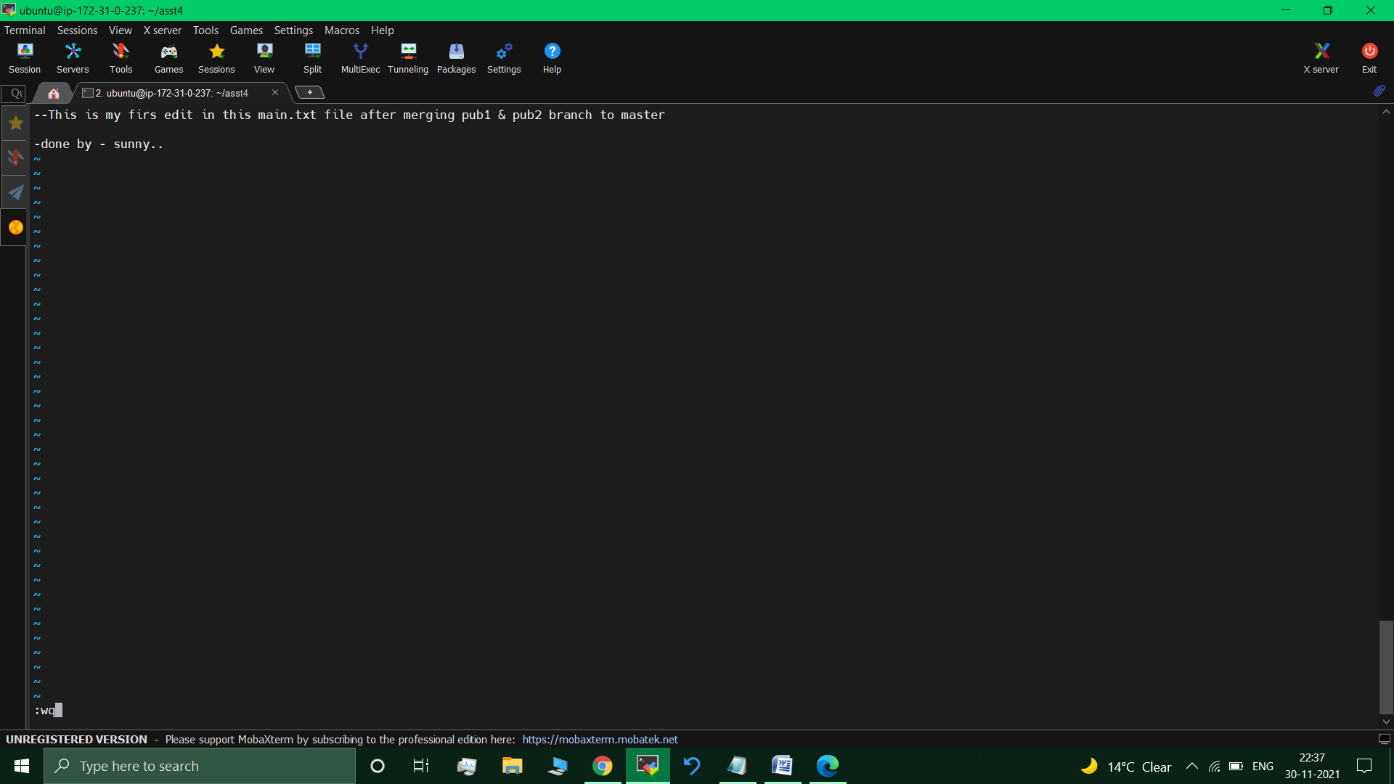

git checkout public1 // M master.txt ( Switched to branch 'public1')

git checkout private master.txt //public1 branch now contains updated master.txt from private branch.

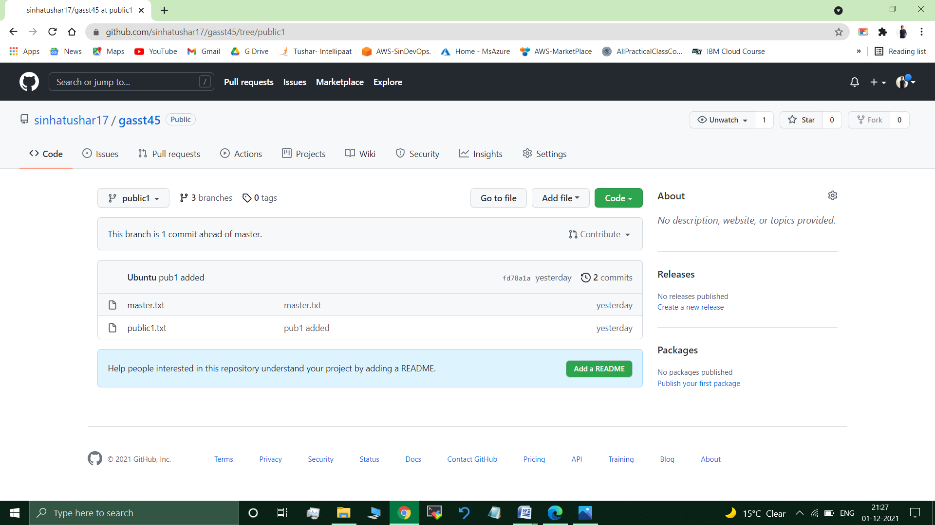

git checkout public2

git checkout private master.txt //public2 branch now contains updated master.txt from private branch.

git checkout master // Switched to branch 'master'

git checkout private master.txt //master branch now contains updated master.txt from private branch.

// Updated public1 & public2 with the new master code in private.

Git push origin private // updated all the code on the private branch.

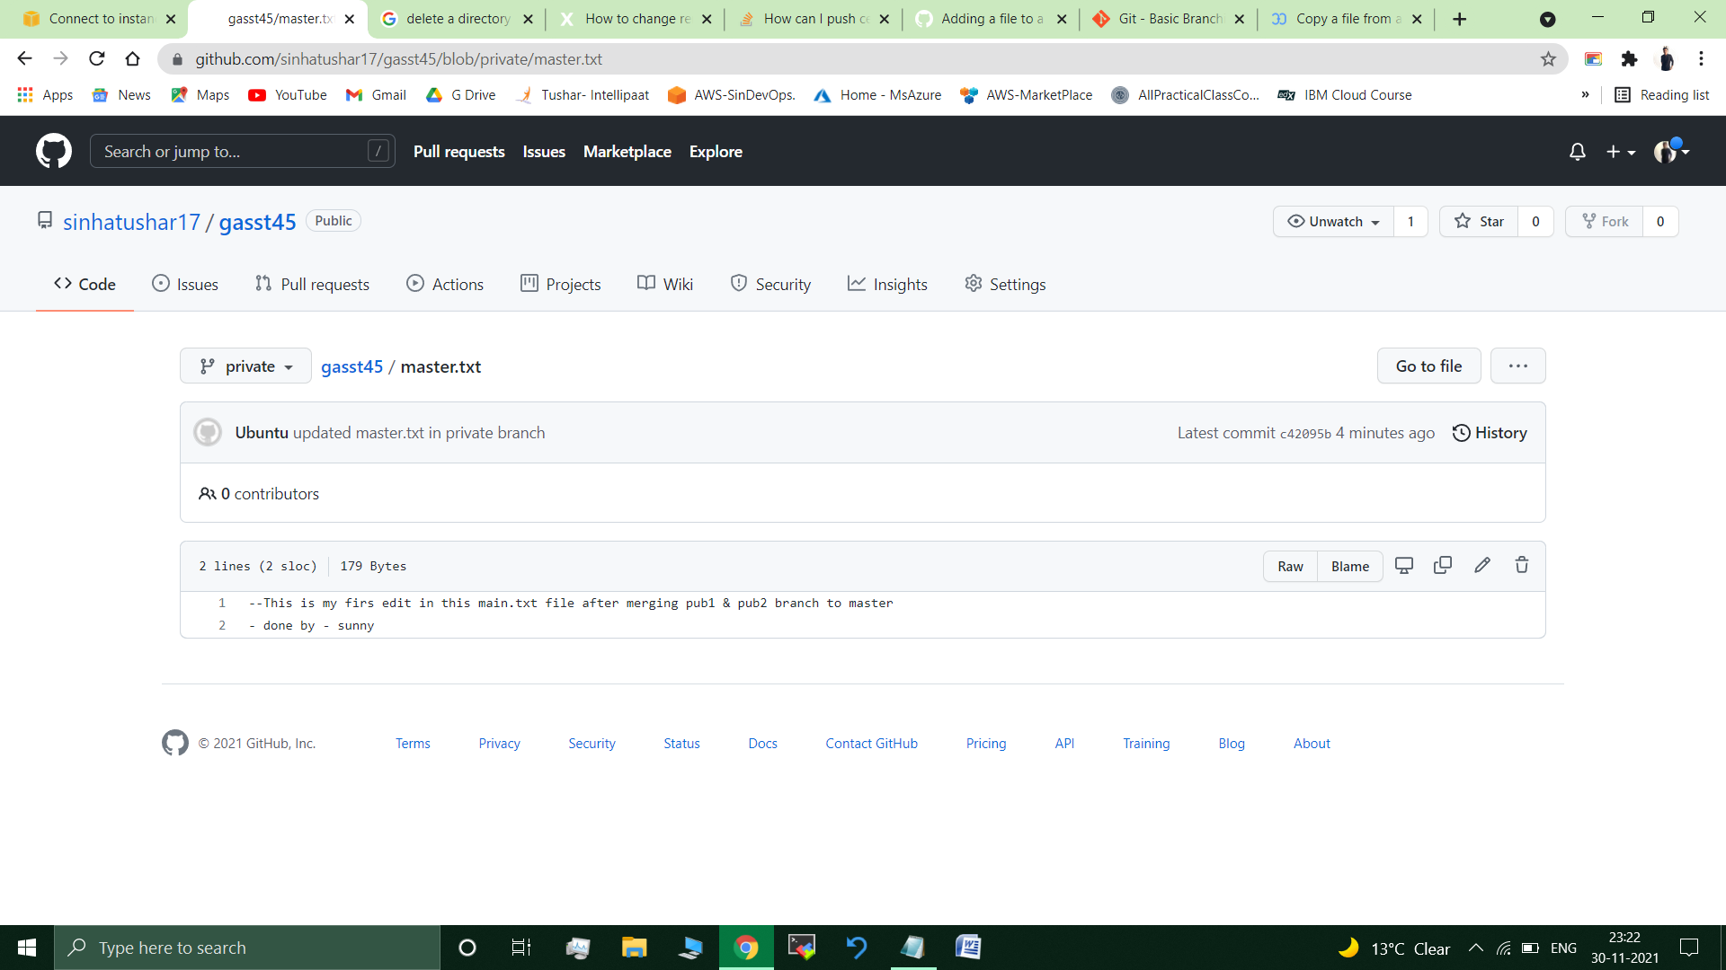

**Submitted By : Tushar Sinha**

**Email ID :** [**sinhatushar17@gmail.com**](mailto:sinhatushar17@gmail.com)

**Enrolled in the “DevOps Architect Master’s Training Program”**